Object Literals, Maps & Sets
We will continue reviewing / practicing the basic concepts from JavaScript. Today learning topic is working with objects in JS. The basic topics about working with objects are:

Object Attributes: In this example, firstName, lastName, and age are attributes of the Person class, and when we create an instance of Person called person1, we initialize these attributes with specific values.

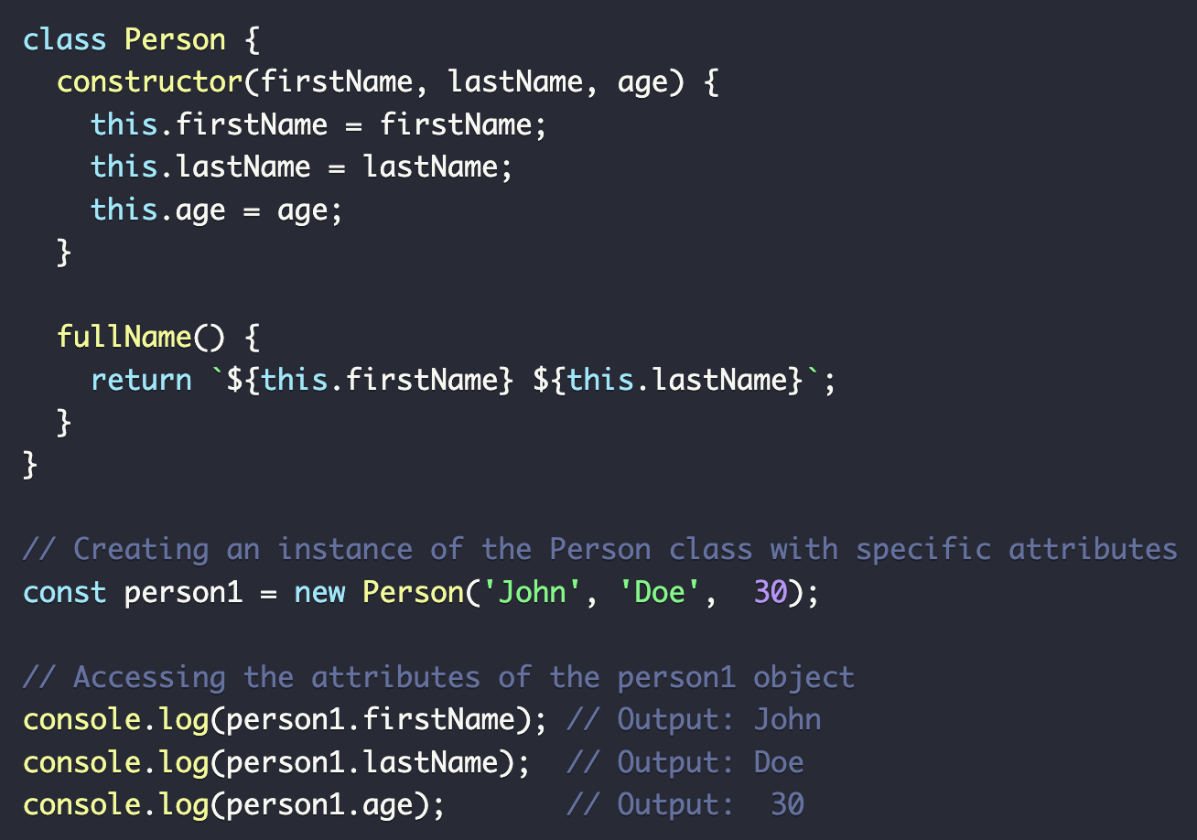

Object Literals: make, model, and year are properties, and startEngine is a method. You can access the properties using dot notation (car.make), using bracket notation (car[make]),
and invoke the method using parentheses (car.startEngine()).
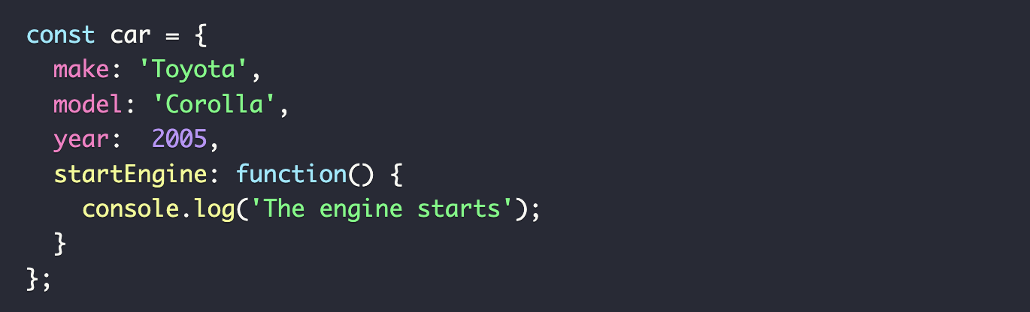
Dot Notation: when you know the name of the property you want to access and it is a valid identifier (meaning it follows the rules for naming variables, such as starting with a letter, underscore, or dollar sign, and not containing spaces or reserved words).

Bracket Notation: the property name is dynamic or determined at runtime, is stored in a variable, or it is not a valid identifier (for example, it contains spaces, starts with a number, or is a reserved word).

Add Properties To An Object: you can use either dot notation or bracket notation to add new key: value pairs

Arrays Are Objects: Here you add two properties to the three element myArray: name and version. When we log myArray, it shows the array elements, but we can also access the properties we've added like any other property on an object.
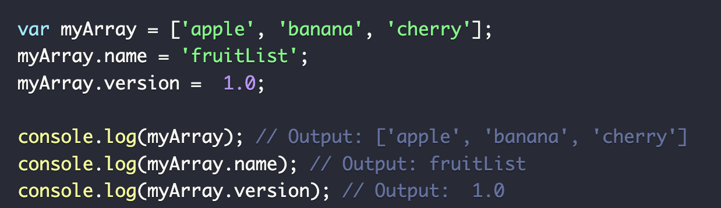

Functions in Objects: Book is a constructor function that creates an object with properties type and author, as well as a method getDetails that returns a string with the details of the book
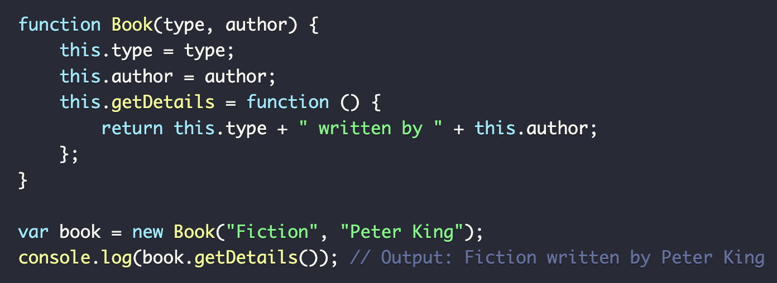

Adding Methods To An Object: you can either add it directly to the object instance or to the object's prototype if you want the method to be shared among all instances of that object
how to add methods to an object

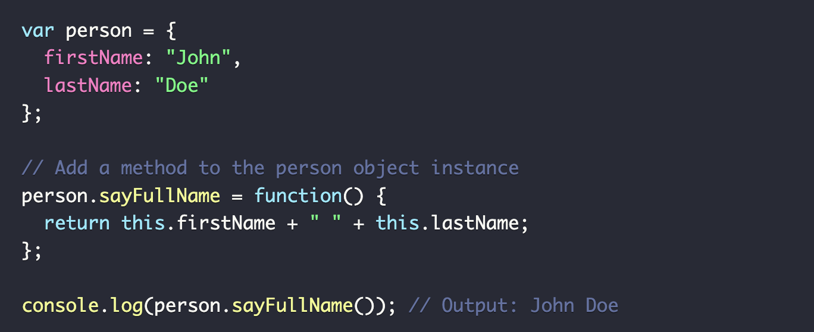
Above, sayFullName is a method added directly to the person object. Below, sayFullName is a method added to the Person prototype, so it is available to all instances created with the new Person() constructor
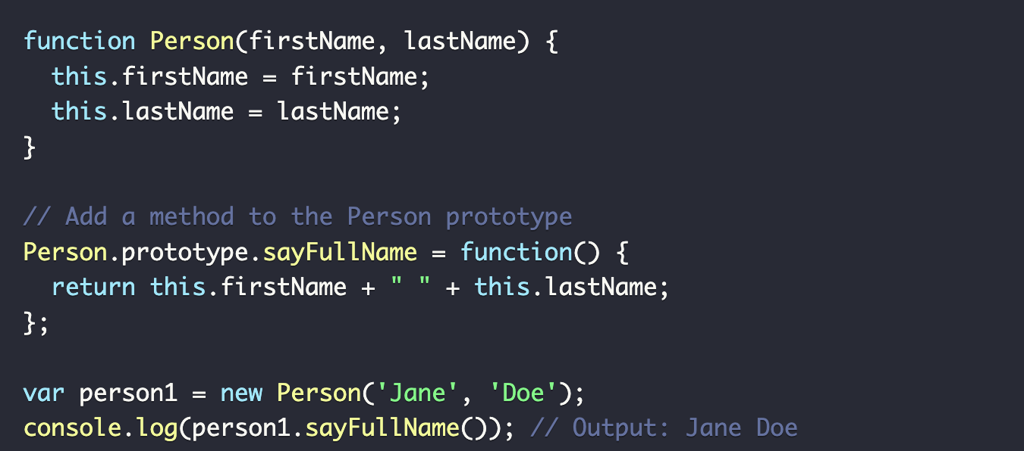
You will see a lot of code challenges for today. Try to solve them all!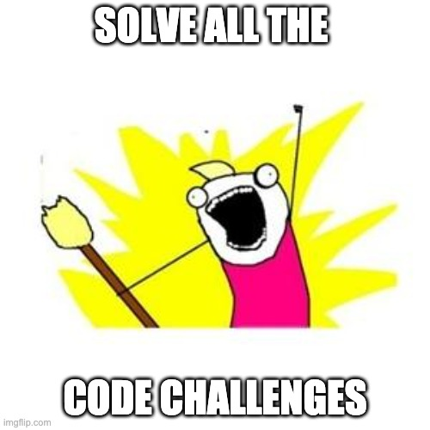
Maps are a new object type that allows storing collections of key-value pairs. See how the keys ('name' and 'age') are associated with their corresponding values ('John' and 30).
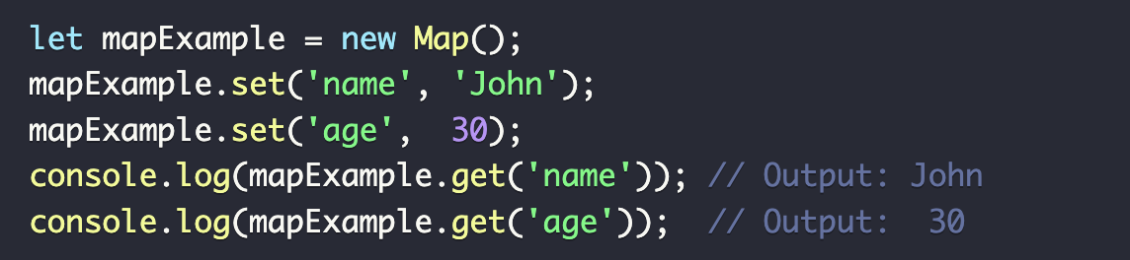

Sets are a new object type with ES6 (ES2015) that allow the creation of collections of unique values, no keys. Notice only unique values are stored, so adding 'apple' a second time has no effect.
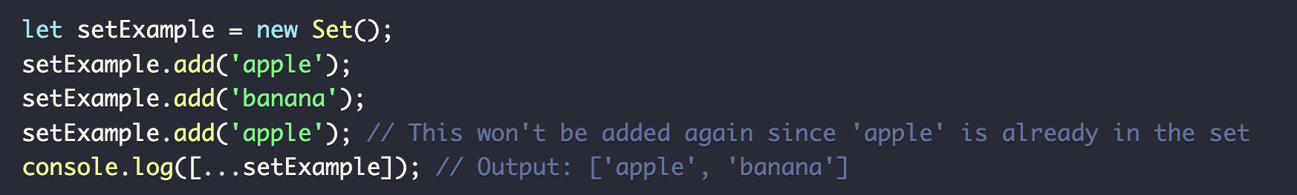

Remember, these are the requirements of your portfolio page:
- 50+ commits
- At least 1 PR
- CSS
  - At least 3 style properties applied to text
  - Border
  - Use of columns
  - Use of at least 1 ID
  - Use of at least 3 web design patterns
  - Override a CSS rule in your code in an obvious way at least once
  - Change display property of at least 1 element
  - Have at least 1 style change for narrow, medium, and wide browser views
- HTML
  - Headers
  - Sections
  - Semantic Tags
  - Links to your social media accounts
  - A contact form asking for a name (required), email (required), phone number (not required), and address (not required). (By not required, I mean the fields need to be present on the form, but they do not need to be filled out in order to submit the form)
  - Add contact information for yourself
  - Photo

Also, please remember this is all practice, so if you don’t get it all done, that is totally fine! It is all about growth.

Optional Resources
⚙️ Complete #1 through #4: JS Fundamentals Challenges
⚙️Developing your brand as a software developer
⚙️JavaScript Maps and Sets
⚙️JavaScript Object Literals

End-of-day questions
- What is the syntax for declaring an Object?
- What are Complex Objects? Give an example.
- Explain some built-in Object Methods in JavaScript.
- What is a property of an Object?
- What is the difference between dot and bracket notation?
- How do you access nested objects inside an array?
- What is a JS Map?
- When should I use a Map?
- What is a JS Set?
- When should I use a Set?

EOD Quiz: Object Literals, Maps, & Sets

